First Star Scholars UK
Risk Management Policy
Date of Last Review | 18/09/2026
Review Cycle | Annually
Date (Month/Year) of Next Review | 09/2027
Date Policy was First Ratified | 29/10/2024
Named Lead for Writing/Review | D Molloy
Signed: Diarmuid Molloy  CEO  Signed: Robert Gratton  FSSUK Board of Trustees – Chair | Date  18/09/26  Date  18/09/26
Introduction
We recognise the importance of effective risk management to achieve First Star Scholars UK’s (the charity) objectives. This policy outlines our commitment to identifying, assessing, and managing risks to ensure our resilience and continued success.

Purpose
The purpose of this policy is to establish a framework for identifying, assessing, prioritising, and managing risks associated with our activities. It aims to ensure a systematic and proactive approach to risk management, protecting the charity, its beneficiaries, and stakeholders.

Scope
This policy applies to all trustees, employees, volunteers, and stakeholders involved in our work. It covers all aspects of the charity’s operations, including but not limited to programmes, finances, reputational risk, and governance. Where necessary, we will create additional relevant policies, such as systems of internal control, due diligence, and health & safety policies.

Risk Management Cycle
Risk is usually managed by means of a cycle of identification, quantification, management, and review.
- Identification - Identify the various risks that may materialise.
- Quantifying - Assess and quantify these risks.
- Managing - Take appropriate action to manage these risks. This is usually the weakest area in a risk management framework. Risks can be managed as follows:

Avoidance - Action that can be taken to avoid a risk occurring.
Mitigation - Action that can be taken to reduce the impact a risk may have, if it occurs.
Buying Out - Generally, this is done using insurance.
Accepting - Risk cannot be eliminated entirely, and any steps taken to manage risk must be reasonable, as resources are not unlimited in terms of money and time. Equally, adopting a purely risk adverse approach limits opportunity.

- Reviewing - Risks should be reviewed as regularly as is necessary, depending on their likely probability and impact in the light of changing circumstances. This may be done on an ongoing basis, at appropriate points in projects or at regular meetings. Risk assessments will be reviewed annually and as needs must on a dynamic basis.

Responsibilities
The board of trustees have overall responsibility for ensuring that there is an appropriate system of controls, financial and otherwise, in place and working effectively. The systems of financial control are designed to provide reasonable, but not absolute, assurance against material misstatement or loss. See Financial Controls Policy. These include:
- a strategic plan and business plan and budget approved by the board of trustees.
- regular consideration by the board of trustees of financial results and variance from budgets.
- delegation of authority and segregation of duties.
- management of risk.
All staff and volunteers have a role in identifying and reporting risks within their respective areas of responsibility.

Risk Identification and Assessment
Risks will be identified through regular risk assessments conducted at least annually. Identified risks will be assessed based on likelihood and impact to determine the level of risk. Risks will be categorised as outlined below:

Risk category | Examples
Governance risks | • inappropriate organisational structure  • trustee body lacks relevant skills or commitment  • conflicts of interest
Operational risks | - lack of beneficiary welfare or safety  - poor staff recruitment and training  - doubt about security of assets
Financial risks | - inaccurate and/or insufficient financial information  - inadequate reserves and cash flow  - partner programme financial management  - dependency on limited income sources  - insufficient insurance cover
External risks | - poor public perception and reputation  - demographic changes such as an increase in the size of beneficiary group  - turbulent economic or political environment  - changing government policy
Compliance with law and regulation | - acting in breach of trust  - poor knowledge of the legal responsibilities of an employer  - poor knowledge of regulatory requirements of particular activities (e.g., fund-raising)

The tables (impact and likelihood) below show how risk is assessed. This allows FSSUK to weigh the nature of the risk and its impact alongside the likelihood of occurrence. FSSUK gives attention to the high impact risks but also notes that a series of low impact risk events could have a greater cumulative impact.

Impact
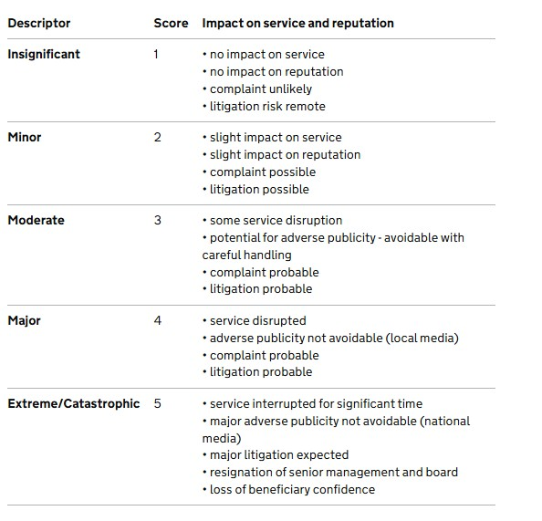

Likelihood

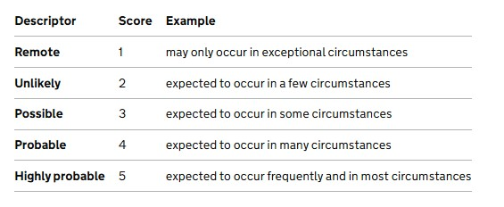
Calculating the initial risk score
The initial risk score is calculated by multiplying the likelihood score by the impact score. For example, a risk with a likelihood of 2 and an impact of 3 would have a score of 6 (2 x 3).
Initial risk score | Level | Action level
1–8 | Low risk | Accept risk. To be managed at the activity level.
9–16 | Medium  risk | Management action required to reduce risk level to low
17–25 High risk Significant risk. Board action/awareness required.

Risk Mitigation and Management
- Strategies for risk mitigation will be developed for high-priority risks.
- Mitigation plans will be assigned to responsible individuals with clear timelines.
- Regular monitoring and reporting on the progress of risk mitigation plans will be conducted.

Reporting and Communication
- A risk register will be maintained and regularly reviewed by the board of trustees.
- Key risks and mitigation efforts will be communicated to relevant stakeholders.
- In its annual report, the board of trustees will report on the steps it has taken to manage risk, to demonstrate the charity's accountability to its stakeholders including beneficiaries, donors, funders, employees, volunteers, and the general public. Current Risks
Current risks can be found in the risk register.

Review and Continuous Improvement
- The risk management policy and processes will be reviewed annually or more regularly as needed.
- Lessons learned from risk events will be used to improve risk management practices.
Training and Awareness
- Staff and volunteers will receive training on risk management principles and practices.
- Regular communication will be conducted to raise awareness of the importance of risk management.
Version Control - Approval and Review
Version No. | Approved by | Approval Date | Main Change | Review Period
1.0 | Diarmuid Molloy | 7 October 2024 | New policy format approved | Annually
1.1 | Diarmuid Molloy | 8 August 2025 | Annual review | Annually
1.2 | Diarmuid Molloy | 18/9/26 | Annual review | Annually

