First Star Scholars UK

# First Star Scholars UK Stack Works Solution Policy

**DIRECTORS AND OFFICERS**

CEO

Mr Diarmuid Molloy

Agreed by Board

25th June 2024

Review date August 2026

Policy 1a/b/c/d / Version 1

**Peter Samuelson**

Samuelson Productions

*First Star Academies UK Chair & Founder*

**Tom Brighton**

Strategic Consultant

*Chair Fundraising Committee*

**Stuart Irvine**

Commercial, Operations & Project Director Chair Finance and Personnel Committee

**Mr Diarmuid Molloy**

*CEO*

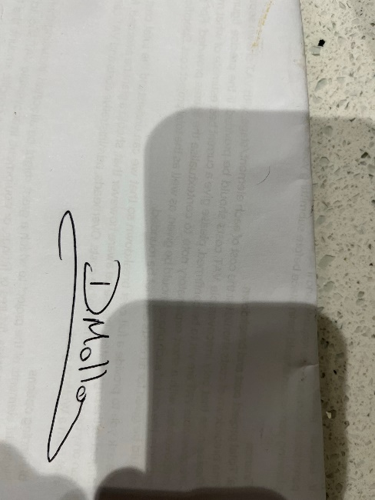

**1. Objective**

To establish a standardized approach for solving problems, managing tasks, and communicating within a stack-based workflow to enhance efficiency, collaboration, and quality of output for First Star Scholars UK. This policy aims to support the organization's mission to improve the lives of young people in care by partnering with schools, social services, carers, universities, and local authorities.

**2. Scope**

This policy applies to all team members, including staff, volunteers, and collaborators, involved in using the stack-based workflow for project management, development, and support tasks at First Star Scholars UK.

**3. Definitions**

* **Stack**: A set of tools and technologies used for development, management, and support tasks specific to First Star Scholars UK.
* **Workflow**: The sequence of processes through which a task passes from initiation to completion within the organization.

**4. Roles and Responsibilities**

* **Team Members**: Follow the stack-based workflow, report issues, and collaborate effectively.
* **Project Managers**: Ensure tasks are assigned, tracked, and completed according to the workflow.
* **Technical Leads**: Provide guidance on technical issues and ensure adherence to the stack technologies.
* **Quality Assurance (QA) Team**: Verify the quality and functionality of the output.
* **Carers and Supporting Adults**: Engage and provide long-term support to scholars as they transition to Higher Education and independence.

**5. Workflow Guidelines**

**5.1 Task Management**

* **Task Creation**: Tasks should be created in the task management tool with clear descriptions, objectives, and deadlines aligned with strategic goals such as keeping scholars on track for GCSE and post-16 educational success.
* **Assignment**: Tasks should be assigned to team members based on expertise and availability.
* **Prioritization**: Tasks should be prioritized based on urgency, impact, and dependencies, focusing on providing resources and support for successful transitions to higher education.
* **Tracking**: Progress on tasks should be regularly updated in the task management tool.

**5.2 Communication**

* **Channels**: Use designated communication channels (e.g., Slack, Teams) for discussions related to tasks.
* **Updates**: Regular updates should be provided during stand-up meetings and through the task management tool.
* **Documentation**: All decisions, changes, and issues should be documented in the relevant project documents.

**5.3 Problem-Solving**

* **Issue Reporting**: Issues should be reported promptly through the issue tracking system.
* **Debugging**: Use stack-specific tools and techniques for diagnosing and fixing issues.
* **Collaboration**: Collaborate with relevant team members to resolve issues efficiently.

**5.4 Quality Assurance**

* **Testing**: All tasks must go through a defined testing process before being marked as complete.
* **Review**: Code reviews and peer reviews should be conducted to ensure quality and adherence to standards.
* **Feedback**: Provide constructive feedback and ensure any identified issues are addressed.

**6. Tools and Technologies**

* **Version Control**: Use Git for version control.
* **CI/CD**: Implement Continuous Integration and Continuous Deployment using tools like Jenkins, Travis CI, or GitHub Actions.
* **Task Management**: Use tools like Jira, Trello, or Asana for task management.
* **Communication**: Use Slack, Microsoft Teams, or similar for team communication.
* **Documentation**: Maintain documentation in Confluence, Notion, or similar platforms.

**7. Training and Support**

* **Training**: Provide regular training sessions on stack technologies and workflow processes.
* **Support**: Ensure support channels are available for addressing technical and operational issues.

**8. Evaluation and Improvement**

* **Regular Reviews**: Conduct regular reviews of the workflow and stack to identify areas for improvement.
* **Feedback Loop**: Establish a feedback loop where team members can suggest improvements to the workflow and tools.
* **Adaptation**: Continuously adapt the stack and workflow to meet the evolving needs of First Star Scholars UK.

**9. Compliance and Governance**

* **Adherence**: All team members must adhere to this policy to ensure consistent and efficient operations.
* **Monitoring**: Project Managers and Technical Leads will monitor compliance with this policy.
* **Reporting**: Any deviations from this policy should be reported to the Project Managers for review and corrective action.

By adhering to this policy, First Star Scholars UK aims to streamline its operations, enhance collaboration, and ensure high-quality outcomes in all its projects and initiatives. This policy supports the strategic goals of nurturing aspiration and life potential, ensuring educational success, and preparing care-experienced young people for independence and adulthood.