First Star Scholars UK

**Safeguarding Policy**

**Designated Safeguarding Officers**

Diarmuid Molloy

Signed:

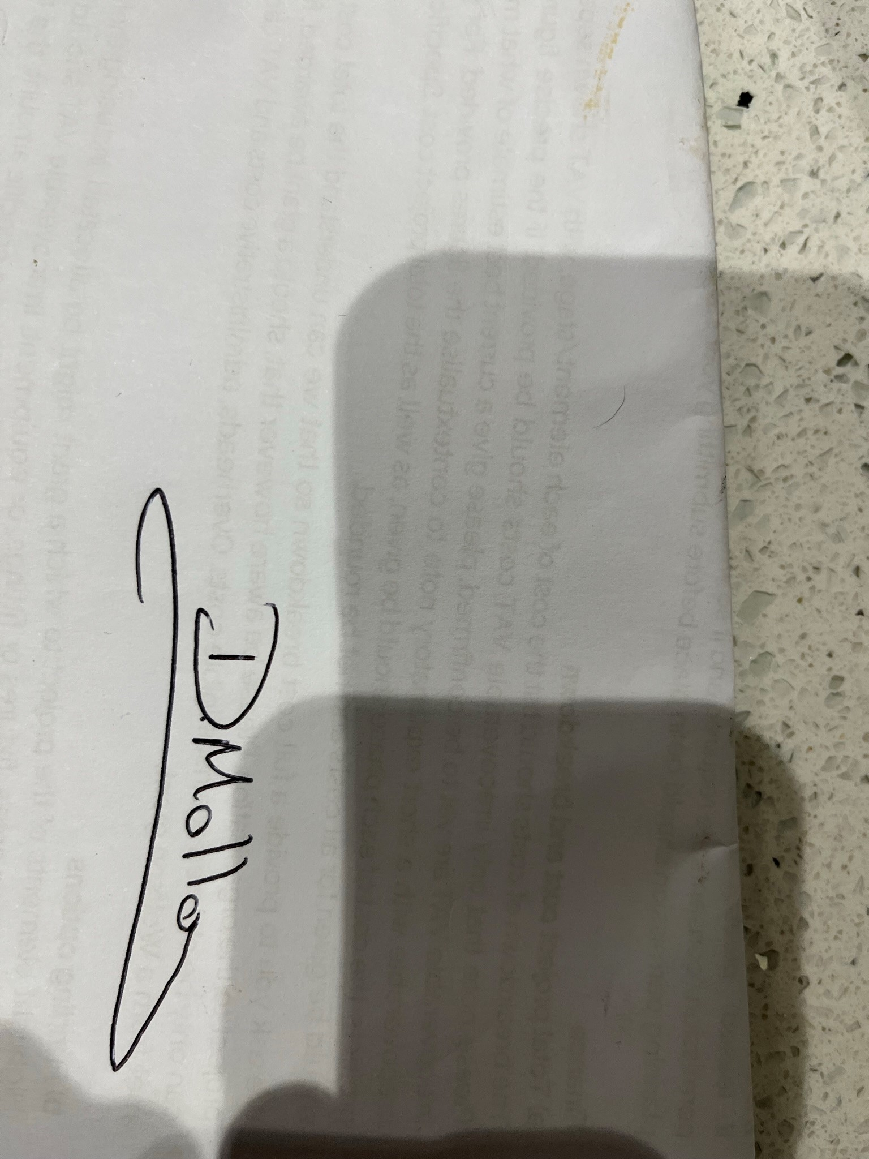

**FS2U Safeguarding Officer**

Andy Hall

**Nominated safeguarding trustee**

Peter Samuelson

**Safeguarding Policy**

Agreed by Board 27th October 2023

Review date

August 2024

# Our safeguarding policy

This policy applies to all staff, including directors and the board of trustees, paid staff, volunteers and sessional workers, external facilitators, students, or anyone working on behalf of First Star Scholars UK or taking part in event hosted by First Star Scholars UK (FSSUK).

The purpose of this policy page 2

Legal framework page 3

Equality statement page 3

Scope page 3

Contact details and policy review page 4

# The purpose of this policy

* To protect children and young people who are programme participants, visitors or who receive FSSUK's services;
* to provide trustees, staff and volunteers working with FSSUK or our programme with the overarching principles that guide our approach to safeguarding and child protection;

First Star Scholars UK believes that a young person should never experience abuse of any kind. We have a responsibility to promote the welfare of all children and young people and to keep them safe from abuse or harm. We are committed to practise in a way that protects them.

* Child or young person - For the purpose of this Policy, the term ‘young person’ applies to a person who is less than 18 years of age;
* Facilitators - Including clients, external groups, organisations, visiting children and individuals in any kind of capacity.
* Volunteers - someone spending time, unpaid, doing something that aims to benefit other people or the environment.
* Safeguarding - Protecting people’s health, wellbeing and human rights, and enabling them to live free from harm, abuse and neglect.
* Abuse or Harm – A person may abuse a child or vulnerable adult by inflicting harm, or failing to act to prevent harm. Abuse or harm may be:
* A single act, of any scale, which causes harm and can be of varying degrees
* Repeated acts of a similar or different nature
* Intentional or unintentional
* An act of neglect or a failure to act on the part of someone who has caring responsibilities

# Legal framework

This policy has been drawn up on the basis of law and guidance that seeks to protect young people, namely:

* Children Act 1989
* United Convention of the Rights of the Child 1991
* Data Protection Act 1998
* Human Rights Act 1998
* Sexual Offences Act 2003
* Children Act 2004
* Safeguarding Vulnerable Groups Act 2006
* Protection of Freedoms Act 2012
* Children and Families Act 2014
* Information sharing: Advice for practitioners providing safeguarding services to children, young people, parents and carers: HM government 2015
* Working together to safeguard children: a guide to interagency working to safeguard and promote the welfare of children: HM government 2015
* Keeping Children Safe in Education 2022 open space processes

This policy should be read alongside policies and procedures on:

* Appendix A - Online Safeguarding
* Appendix B - Role of Designated Safeguarding Officer
* Appendix C- Dealing with disclosures and concerns about a young person
* Appendix D - Managing allegations against staff and volunteers
* Code of conduct for directors, trustees, staff and volunteers
* Safer Recruitment
* E safety
* Photography and sharing images policy
* Whistle blowing policy
* Mobile phone policy
* GDPR policy

# Equality statement - We recognise that:

The welfare of the young person is paramount, as enshrined in the Children’s Act 1989;

Some young people are particularly vulnerable because of the impact of previous experiences, their level of dependency, communication needs or other issues;

Working in partnership with young people, their carers and social workers, virtual school head and other agencies is essential in promoting their welfare;

Our programmes are open to all eligible young people regardless of educational progress, age, disability, gender reassignment, race, religion or belief, gender or sexual orientation.

**Scope** - We will seek to keep young people safe by:

* Valuing them, listening to them and respecting them;
* Appointing a designated safeguarding officer (DSO) for young people and a nominated board member for safeguarding;
* Ensuring directors and staff are DBS checked and have undertaken appropriate safeguarding training on an annual basis;
* Ensuring training and procedures are secure within our First Star 2U provision;
* Adopting child protection and safeguarding practices through procedures and a code of conduct for trustees, staff, facilitators and volunteers;
* Holding our partner providers – First Star programmes to account for their safeguarding policies and practices;
* Developing and implementing and effective e-safety policy and related procedures;
* Providing effective management for staff and volunteers through supervision, support, training and quality assurance measures;
* Recruiting trustees, staff and volunteers safely, ensuring all necessary checks are made;
* Recording and storing information professionally and securely, and sharing information about safeguarding and good practice with young people, their social workers, carers, FSSUK staff and volunteers via leaflets, posters, one-to- one discussions;
* Using our safeguarding procedures to share concerns and relevant Information with agencies who need to know, and involving young people, their carers, social workers, and university programme staff appropriately;
* Using our procedures to manage any allegations against trustees, staff, volunteers or peers appropriately;
* Creating and maintaining an anti-bullying environment and ensuring that we have a policy and procedure to help us deal effectively with any bullying that does arise;
* Ensuring that we have effective complaints and whistleblowing measures in place;
* Ensure compliance with GDPR, online safeguarding and risk management policies;

# Working with Partners

First Star Scholars UK has partnerships with universities in the provision of our campus programme. University partners must have their own safeguarding and child protection polices, protocols and DSO. Memorandum of Agreement requires DSO and safeguarding policy. Where staff, including directors, mentors and youth coaches, are employed by the university safeguarding training and DBS checks must be provided by the university and confirmed by the director.

First Star 2U programme staff, including the director, mentors and youth coaches, are employed by First Star who is responsible for providing safeguarding training and confirming DBS checks.

# Contact details

*Designated Safeguarding Officer (DSO)*

Name Diarmuid Molloy

Phone 07933686271

Email [diarmuid.molloy@firststaruk.org](mailto:diarmuid.molloy@firststaruk.org)

Name Andy Hall

Phone 07510 350574

Email andy.hall@firststaruk.org

*Nominated Safeguarding Lead – Board of Trustees Peter Samuelson* [peter.samuleson@firststaruk.org](mailto:peter.samuleson@firststaruk.org)

CEOP - [www.ceop.police.uk](http://www.ceop.police.uk)

NSPCC Helpline 0808 800 5000

This policy was last reviewed on: June 2022

We are committed to reviewing our policy and good practice **annually**.

Signed:

Pp Peter Samuelson (electronic vote 23rd July 2023)

………………………….....................................................................................

(Signed by the safeguarding lead on FSSUK Board of Trustees)